Biomimetic studies on the mechanism of stereoselective lanthionine formation

Supporting Information

Yantao Zhu, Matt D. Gieselman, Hao Zhou, Olga Averin,

and Wilfred A. van der Donk*

Separation of the various diastereomers of 5.
A Whelk-O1 chiral stationary column was used to determine the stereochemical purity of anti-8 prepared according to Scheme 2. A single peak was observed (Fig. A) under conditions when all four diastereomers of 8 prepared by Michael addition to Z-dehydrobutyrine (Scheme 2) are resolved (Fig. B, 1% ^{i}PrOH in hexane at 1 mL/min). Coinjection of the racemic and pure material confirmed the stereochemical purity of anti-8: since it is the last eluting peak, its enantiomer cannot be buried under the tail of the peak and would have been visible in Fig. A if present.

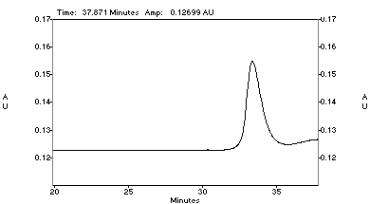(A) (2R,3S)-8 (anti-8) (B) ± syn- & anti-8 (C) Coinjection of (2R,3S)-8
and ± syn- & anti-8

Cleavage of peptides from resins.¹ The resin was isolated by filtration, washed with ethanol (1 mL) and CH₂Cl₂ (2 x 1 mL), and dried in vacuo in a desiccator for 1 h. In general the peptides were cleaved with water (0.5 mL), anisole (0.5 mL), thioanisole (0.5 mL), and TFA (10 mL). When cleavage of the Trt-group from Cys was desired, triisopropylsilane was added to the cocktail. The cleavage reactions were stirred at rt for approximately 2 h. The solution was filtered through a coarse frit into a 250 mL round bottom flask and the vial was rinsed with TFA (4 x 1 mL). TFA was removed by rotary evaporation at 30 °C, and diethyl ether (10 mL) was added to precipitate the peptide. The resulting white residue was recovered by filtration. The peptides were analyzed and purified by RP-HPLC on Vydac C-18 columns (0.46 cm x 25 cm analytical, 2.2 cm x 25 cm preparative). They were eluted in 0.1% TFA in acetonitrile/water with linear gradients optimized for each peptide with a flow rate of 1 mL/min on the analytical column and 8 mL/min on the preparative column.
¹ Rainin PS3 Automated Solid Phase Peptide Synthesizer: User Guide; Rainin Instrument Company, 1998.

COSY NMR spectrum of the product obtained from cyclization of both E-1 and 19.

